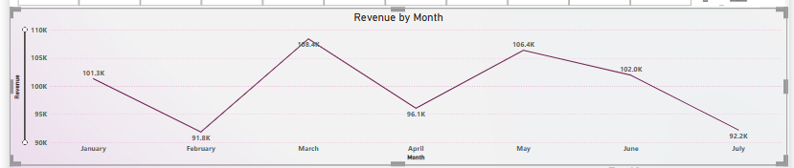**Statistical Analysis**

1. Highest revenue was recorded in March (108.2K), while the lowest was in February (91.8K).
2. The average monthly revenue over 7 months is approximately 99.7K, with noticeable fluctuations month-to-month.

**Business Insights**

1. March and May were strong performing months, indicating successful campaigns or seasonal demand peaks.
2. February and July showed dips in revenue, highlighting the need for improved strategies or promotions during those periods.

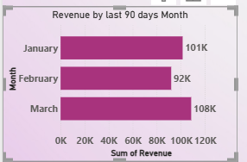

**Statistical Analysis**

1. March recorded the highest revenue at 108K, followed by January (101K) and February (92K).
2. There is a 16K revenue gap between the highest (March) and lowest (February) months, indicating a moderate variation in monthly performance.

**Business Insights**

1. The upward trend from February to March shows a strong recovery or successful campaign that boosted revenue.
2. February’s dip may indicate seasonal weakness or lack of effective promotions, suggesting a need for targeted improvements.

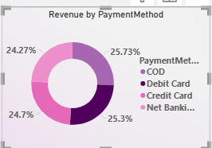

**Statistical Analysis**

1. COD (25.73%) is the most used payment method, closely followed by Credit Card (25.3%), Net Banking (24.7%), and Debit Card (24.27%).
2. The revenue distribution is relatively balanced across all four payment methods, with only about 1.5% variation between the highest and lowest contributors.

**Business Insights**

1. All payment methods are performing well, indicating customers are comfortable using multiple payment options.
2. Since COD leads slightly, offering additional benefits (e.g., instant discounts) on digital payments could shift more users toward online modes, reducing operational risk and returns.

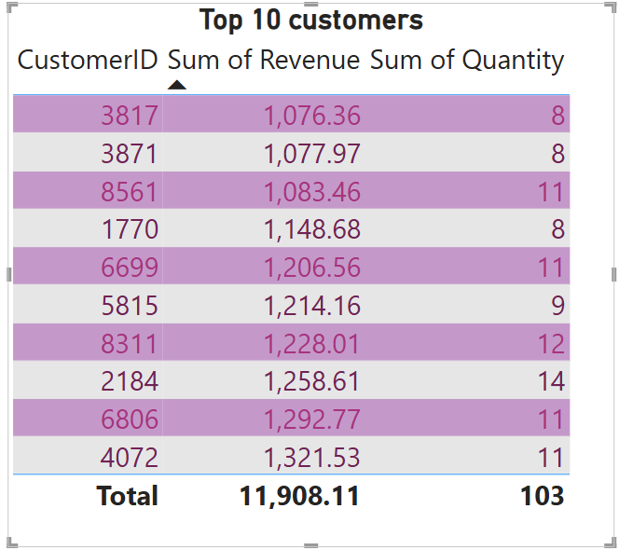

**Statistical Analysis:**

1. Total Revenue and Quantity:

The top 10 customers collectively contributed ₹11,908.11 in revenue and 103 units in quantity, suggesting a strong average transaction value per customer (~₹1,190.81).

1. Distribution of Quantity:

The quantity ranges from 8 to 14 units, indicating relatively low variation. This suggests a fairly consistent purchasing pattern among top customers.

**Business Insights:**

1. High Revenue per Customer:

Each top customer contributes over ₹1,000 in revenue, with the highest being ₹1,321.53 (CustomerID 4072). Focusing retention efforts on these high-value customers could significantly impact profitability.

1. Customer Segmentation Opportunity:

Since some customers (e.g., ID 2184 with 14 units) buy in larger quantities, they may represent bulk buyers or loyal repeat customers. These could be targeted for exclusive offers or loyalty programs

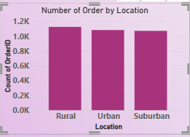

**Statistical Analysis:**

1. Order Distribution Across Locations:

All three locations—Rural, Urban, and Suburban—have a similar number of orders, each around 1,000+, indicating a relatively balanced distribution.

1. Slight Rural Lead:

The Rural region has a marginally higher number of orders compared to Urban and Suburban areas, suggesting minor but measurable variation in order frequency.

**Business Insights:**

1. Strong Rural Demand:

Contrary to common expectations, Rural areas are leading in order volume. This indicates a valuable and possibly underserved customer segment worth investing in (e.g., faster logistics, targeted campaigns).

1. Uniform Market Potential:

Since all three areas show similar order volumes, the business can apply broad marketing strategies across regions without needing drastically different campaigns.

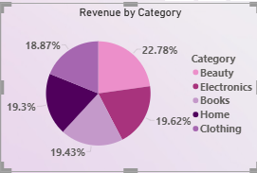

**Statistical Analysis:**

1. Highest Revenue Share:

The Beauty category leads with 22.78% of total revenue, showing a noticeable edge over others.

1. Even Distribution:

Other categories like Clothing (19.62%), Home (19.43%), Electronics (19.3%), and Books (18.87%) are closely clustered, indicating a balanced revenue spread across categories.

**Business Insights:**

1. Invest in Beauty Category:

Given its top performance, the Beauty segment could benefit from expanded product lines or promotions to further boost revenue.

1. Maintain Variety Across Categories:

The near-equal revenue distribution suggests customers value diverse offerings—all product categories are contributing significantly and should be maintained or optimized.

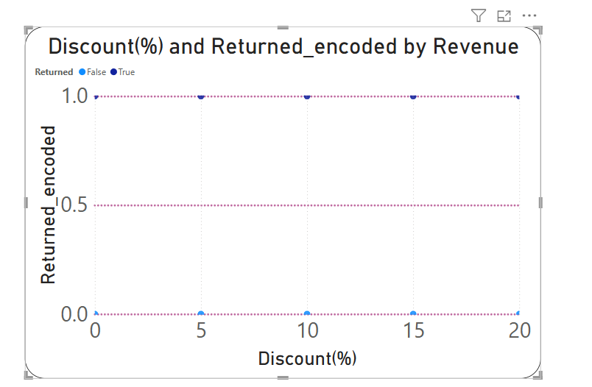

**Statistical Analysis:**

1. Return Pattern Unaffected by Discount:

Data points are consistently along both 0 (Not Returned) and 1 (Returned) across the discount range, suggesting no clear correlation between discount percentage and return behavior.

1. Low Return Frequency:

A majority of data points are concentrated at Returned = 0, indicating that most purchases are not returned regardless of discount level.

**Business Insights:**

1. Discounts Do Not Increase Returns:

Since return rates remain low across all discount levels, the company can offer discounts confidently without a high risk of returns.

1. Focus on Other Return Drivers:

Returns may be influenced more by product quality or category, not discount size. Deeper analysis into return reasons by product type may uncover actionable insights.